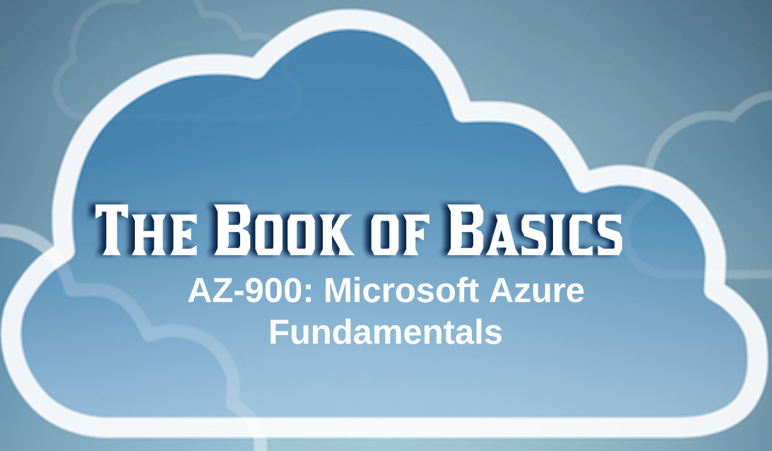

**Cloud Concepts**

**IaaS** - Infrastructure as a Service

**PaaS** - Platform as a Service

**SaaS** - Software as a Service

**Cloud Models:** Public, Private, and Hybrid

**High Availability:** Maintaining **acceptable continuous performance** despite temporary load fluctuations or failures in services, hardware, or data centers.

**Fault Tolerance:** A system´s ability to **continue operating properly** when one or more of its components fails.

**Disaster Recovery:** A system´s ability to **back up and restore data/apps/resources** when needed.

**Scalability** - the ability to increase the instance count or size of existing resources.

**scaling out** - increase instance count of existing resources, non-disruptive

**scaling up** - increase instance size of existing resources, disruptive

**Elasticity** - the ability to increase or decrease the instance count or size of existing resources based on fluctuations in traffic, load, or resource workload.

-ability to scale in both directions (in + out, up + down)

-can be manual or automatic

-based on changes in load or workload

-pay only for what you use

Capital Expense (**CapEx**)

-up-front investment

-creates benefits over a long period of time

-usually non-recurring

-usually related to purchase of permanent assets

Operating Expense (**OpEx**)

-no up-front investment

-creates immediate benefits

-recurring cost of doing business

-usually not related to purchase of permanent assets

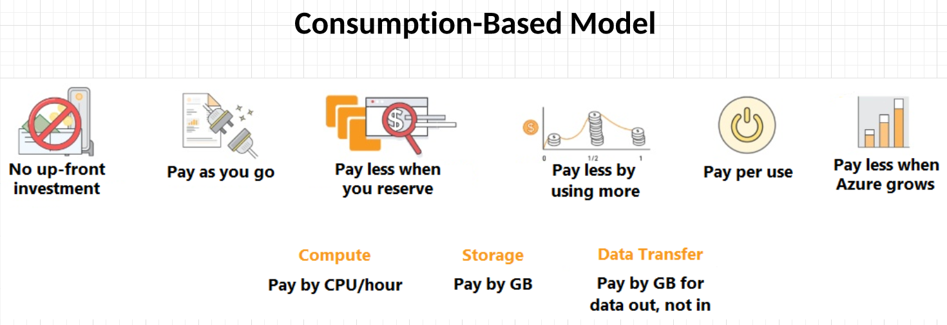

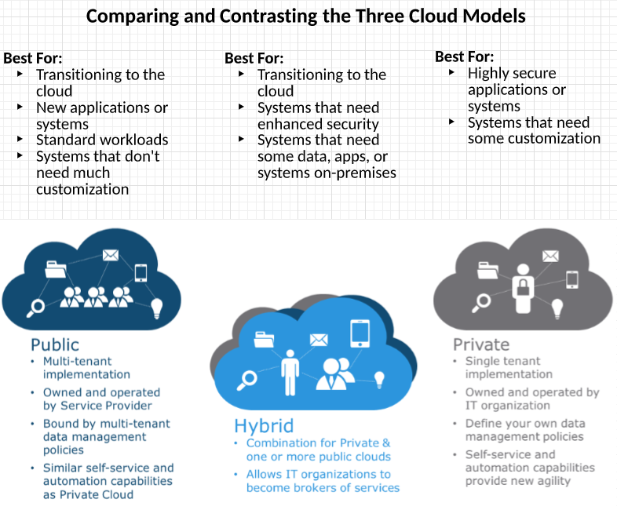

**IaaS** - VM, VNET

**PaaS** - Storage, Search, SQL, App Service

**SaaS** - Salesforce, Office365

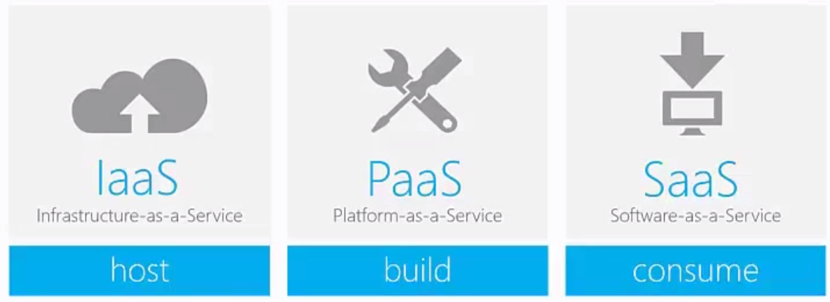

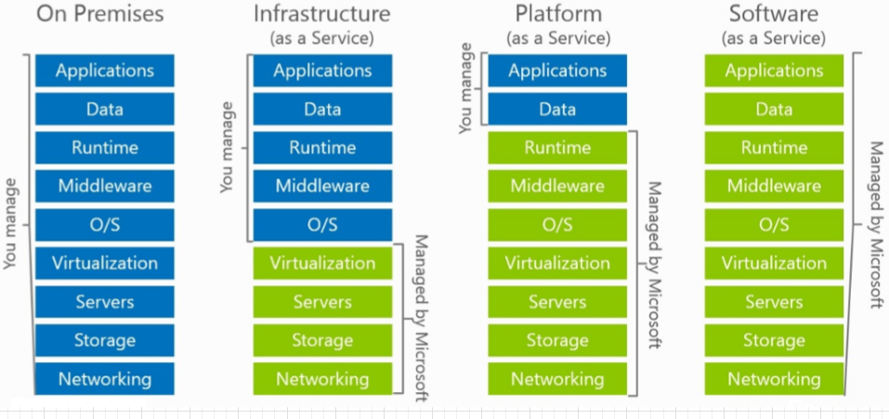

**Core Azure Services**

**Region**

Groups of multiple Azure data centers within a latency-defined perimeter and connected through a dedicated regional low-latency network.

Deploying your applications/systems to multiple regions allows for resiliency to region-wide outages

Multi-Region Failover (Active/Passive):

-Failover across regions instantly

-Resiliency to region-wide outages

-Best when all users are in the same region

Multi-Region Deployments (Active/Active):

-Distribute traffic/load across regions

-Resiliency to region-wide outages

-Best when all users are in different regions

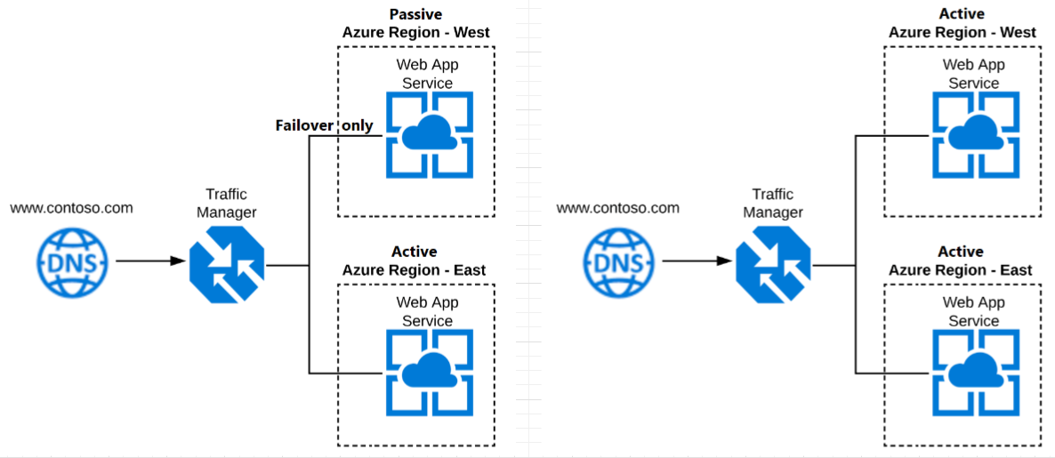

**Availability Zones**

-Unique physical locations within an Azure region made up of one or more data centers

-Allow for high availability by protecting your applications and data from data center failures

-Some Azure services can be deployed to two or more Availability Zones within an Azure region

**Resource Group**

Containers of related Azure services grouped together.

-All the resources in the group should share the same lifecycle - they should be deployed, updated, and deleted together.

-A resource can only exist in one resource group.

-A resource group can contain resources that are located in different regions.

-A resource group can be used to scope access control for administrative actions.

-A resource can interact with resources in other resources groups. (when two resources are related but don´t share the same lifecycle; for example, web apps connection to a database.)

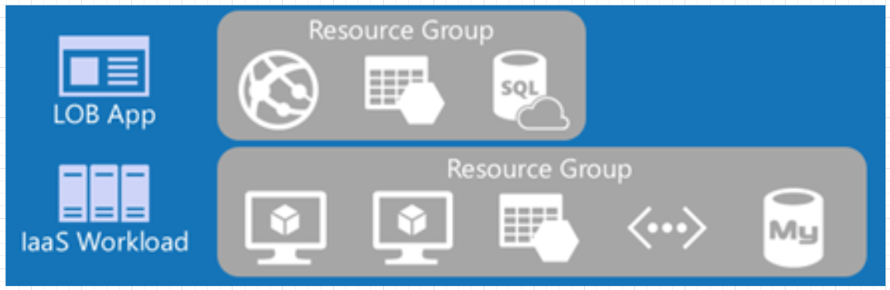

**Azure Resource Manager**

-The Azure **deployment and management service**

-Provides a consistent management layer that enables you to **create, update, and delete** resources in your Azure subscription, including with templates.

-You can use its **access control, auditing, and tagging** features to secure and organize your resources after deployment

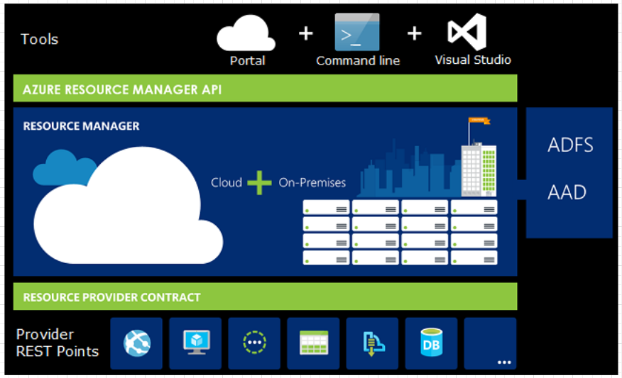

**Azure Architecture: Usage and Benefits**

**Availability Zones**: Allow for high availability by protecting your applications and data from single data center failures.

**Regions**: Deploying your applications/systems to multiple regions allows for high availability and resiliency to region-wide outages

**Resource Groups**: Containers of related Azure services grouped together for administrative and access control actions

**Azure Resource Manager**: Single, centralized, deployment and management service that enables you to create, update, and delete resources in your Azure subscription.

**Azure Products and Services**

**Compute**

**Virtual Machines**

-On-demand, scalable computing resource

-Choose the CPU/RAM size(s) you need

-Most control over server

**Virtual Machine Scale Sets**

-Auto-scaling pool of virtual machines

-Centrally manage, configure, and update a large number of VMs

**App Service (Web App, API app, Mobile Apps)**

-On-demand, auto-scaling, web/mobile/API app hosting

-Linux & Windows platforms

**Serverless Functions (Functions, Logic App)**

-Event-drive, serverless compute resources

-Auto-scale on-demand

-Pay only for what you consume

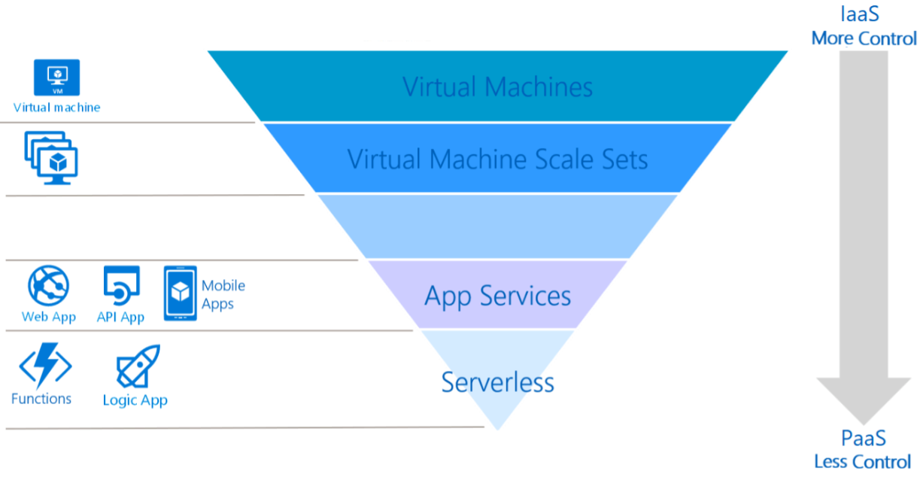

**Networking**

**Azure Virtual Network**

-Enables Azure resources, such as Azure Virtual Machines (VMs), to securely communicate with each other, the internet, and on-premises networks

**Azure Load Balancer**

-Enables you to load-balance incoming internet traffic to your VMs

**Azure VPN Gateway**

-Used to send encrypted traffic between an Azure virtual network and an on-premises location over the public internet or between Azure virtual networks over the Microsoft network

**Azure App Gateway**

-A web traffic load balancer that is even more customizable than Azure Load Balancer

**Azure Content Delivery Network**

-Efficiently delivers web content from locations that are close to end users to minimize latency

**Storage**

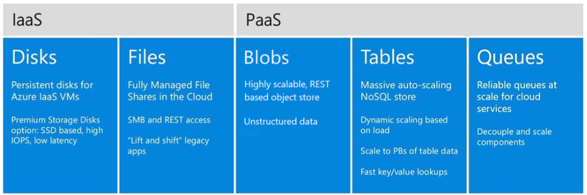

**Azure Storage Tiers**

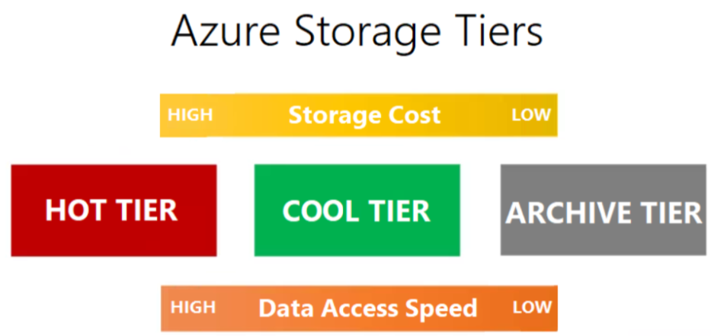

**Databases**

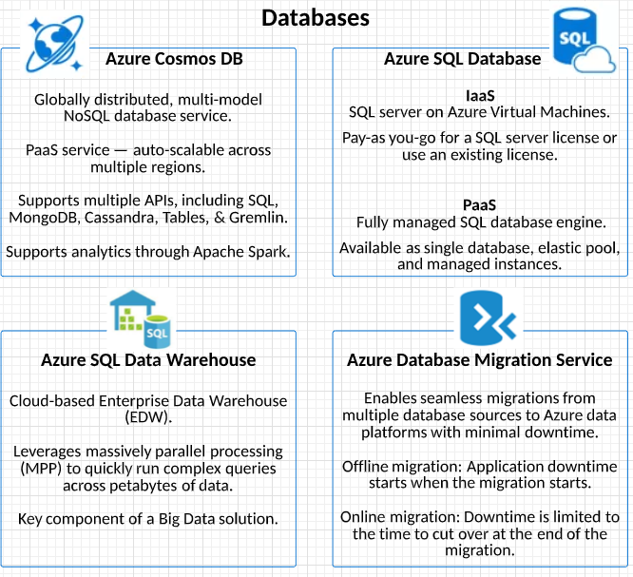

**The Azure Market place**

-An online applications and services marketplace with over 8000 listings

-Offers technical solutions and services from Microsoft and partners that are designed to extend Azure products and services

-Offers SaaS applications, Virtual Machines, Solution Templates, and Azure Managed Applications

-Discover, try, and buy cloud software solutions built on or for Azure

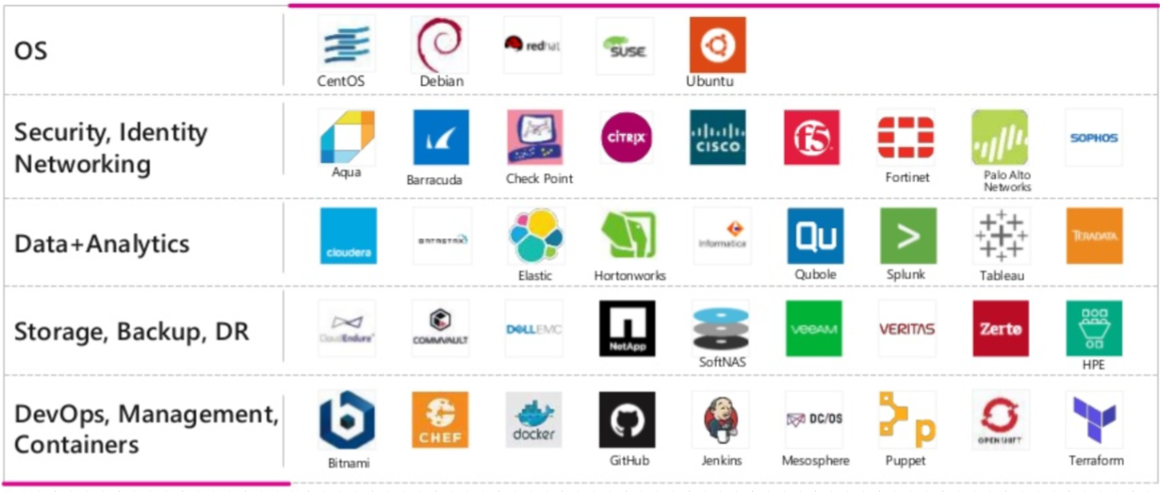

**Azure Solutions**

**Internet of Things (IoT)**

-An IoT solutions is made up one or more IoT devices and one or more back-end services running in the cloud that communicate with each other

-Devices usually have sensors and connect to the internet

**Azure IoT Central**

-Fully managed SaaS solution

-Easily connect, monitor, and manage your IoT devices/assets at scale

-Collaborative, drag-and-drop visual workspace where you can build, test, and deploy IoT solutions without the need to write code

**Azure IoT Hub**

-Core Azure PaaS messaging service used by Azure IoT Central

-Enables reliable and secure bidirectional communications between millions of IoT devices and a cloud solution

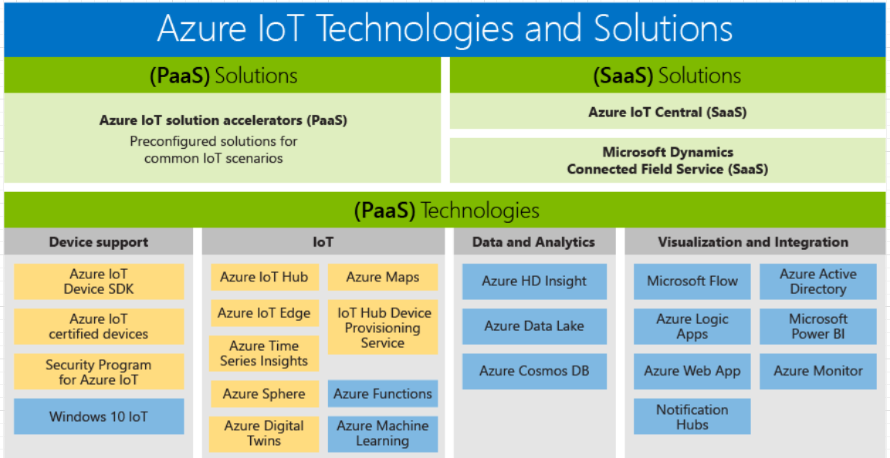

**Big Data and Analytics**

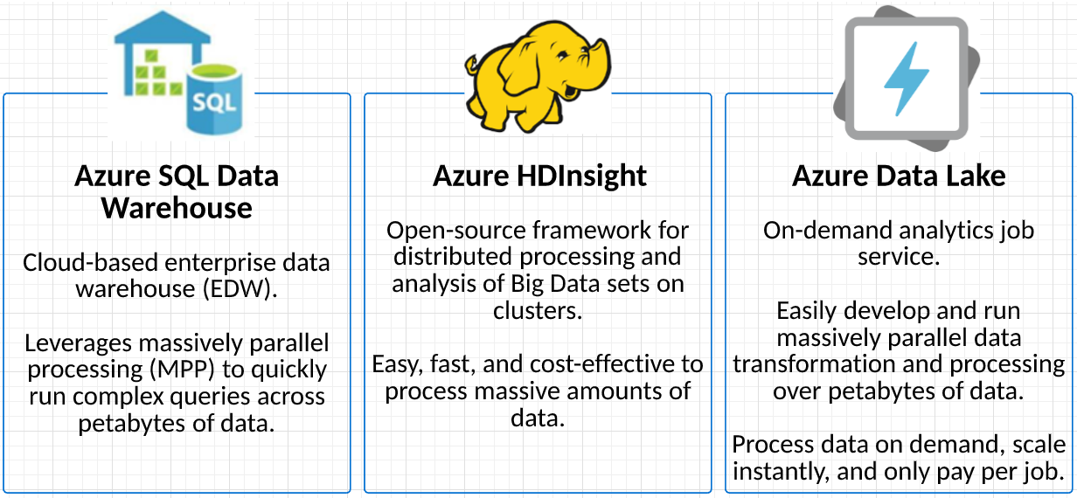

**Artificial Intelligence (AI)**

What is Machine Learning?

-Machine learning is a data science technique that allows computers to use existing data to forecast future behaviors, outcomes, and trends.

-With machine learning, computers learn without being explicitly programmed.

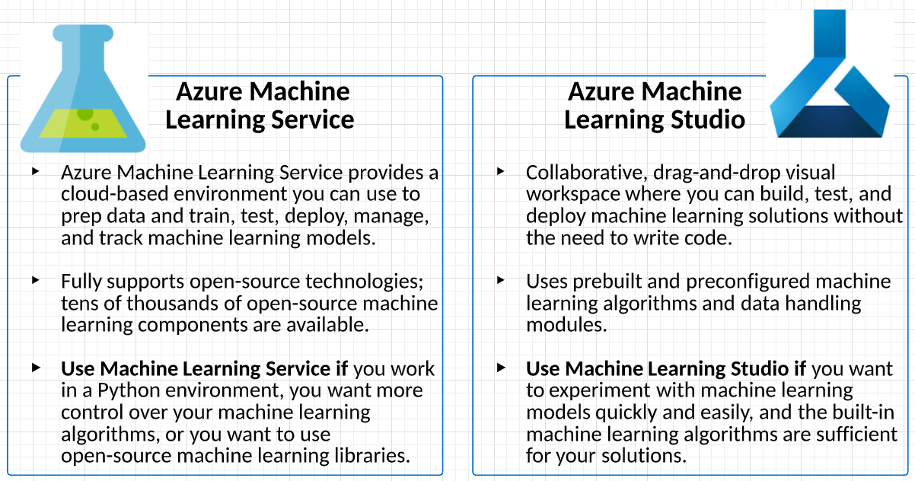

**Serverless Computing**

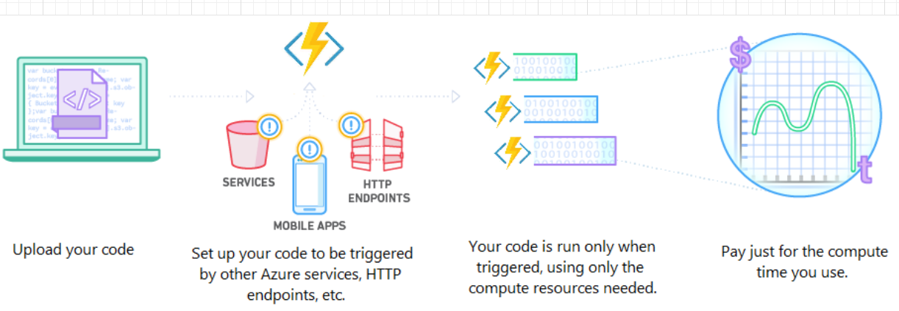

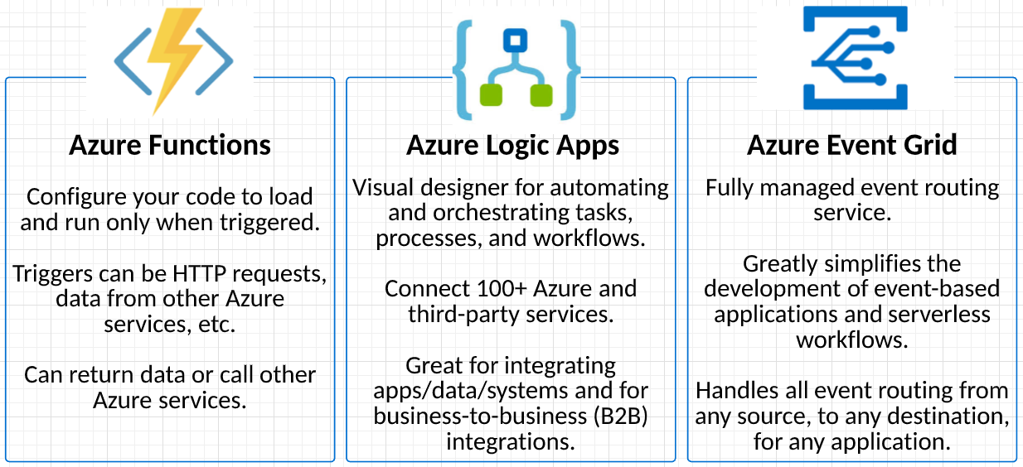

**Azure Solutions: Benefits**

-Using pre-built or pre-packaged solutions reduces costs and shortens the time it takes to set up, configure, and deploy your applications

-Lower skill level needed to set up and administer solutions

-Spend more time focusing on your business and apps, not connecting various Azure services together

**Azure Management Tools**

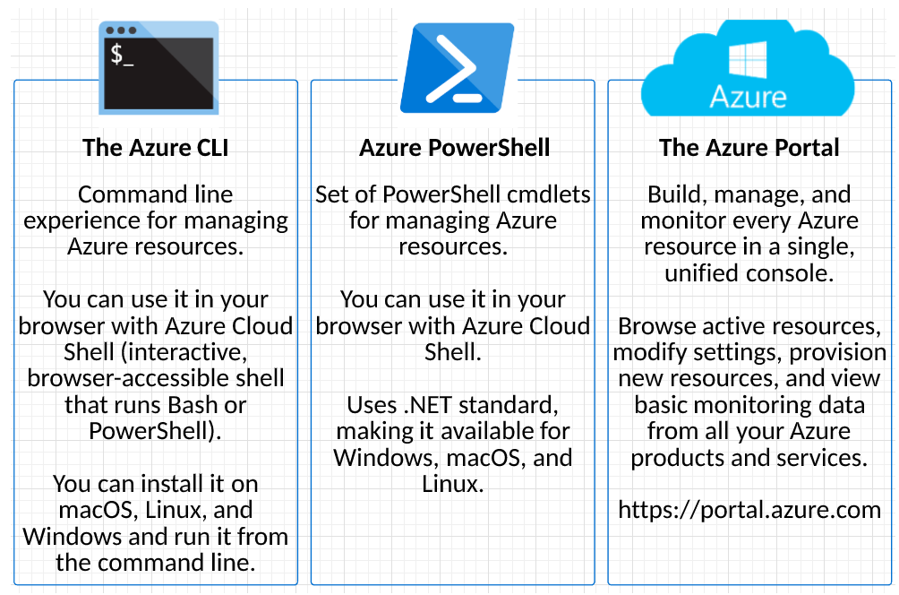

**Azure Advisor**

-Personalized cloud consultant that helps you follow best practices to optimize your Azure deployments

-Analyzes your resource configuration and usage telemetry

-Recommends solutions to help improve the cost effectiveness, performance, security, and availability of your resources

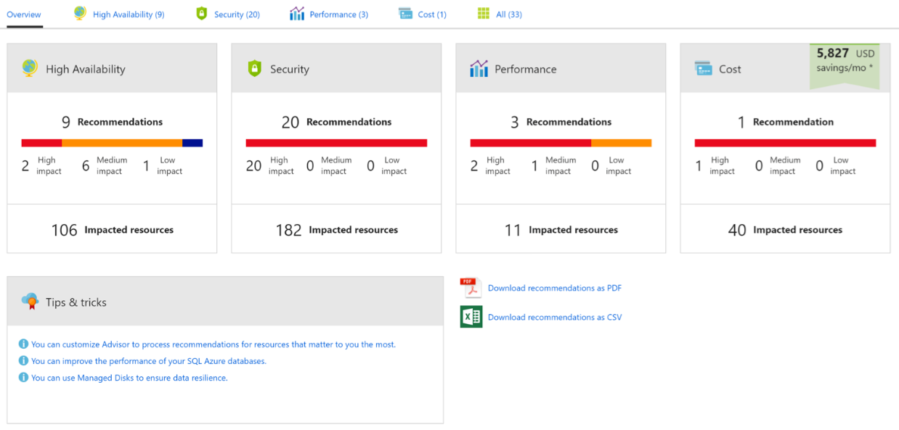

**Network Security**

**Azure Firewall**

-Managed, cloud-based network security service that protects your Azure Virtual Network resources

-Centrally create, enforce, and log application and network connectivity policies across subscriptions and virtual networks

-Fully integrated with Azure Monitor for logging and analytics

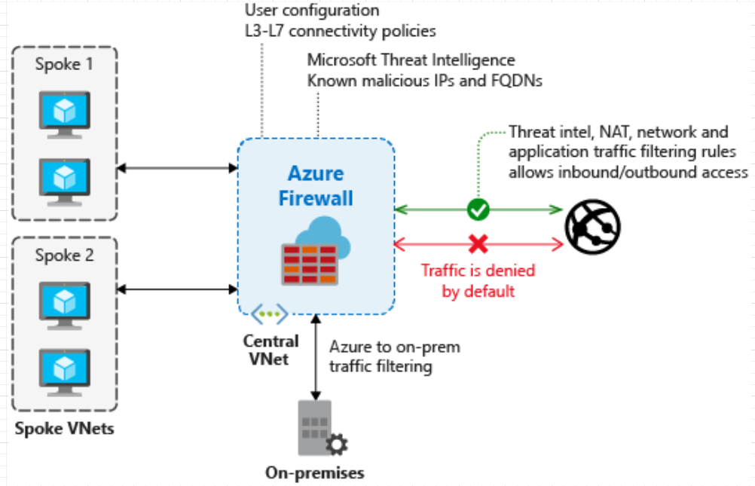

**Azure DDoS protection**

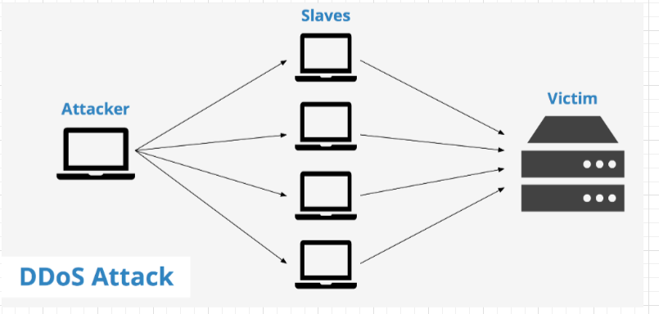

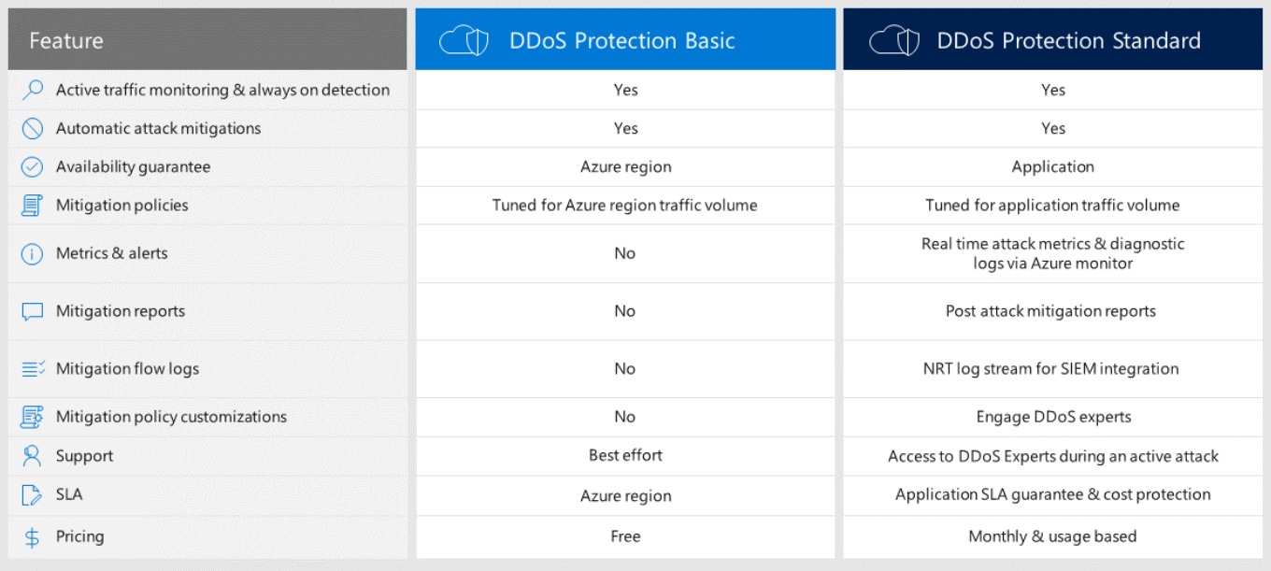

**Network Security Groups (NSGs)**

-Enforce and control network traffic rules at the networking level

-Security rules allow or deny inbound network traffic to, or outbound network traffic from, several types of Azure resources

-For each rule, you can specify a source, destination, port, and protocol

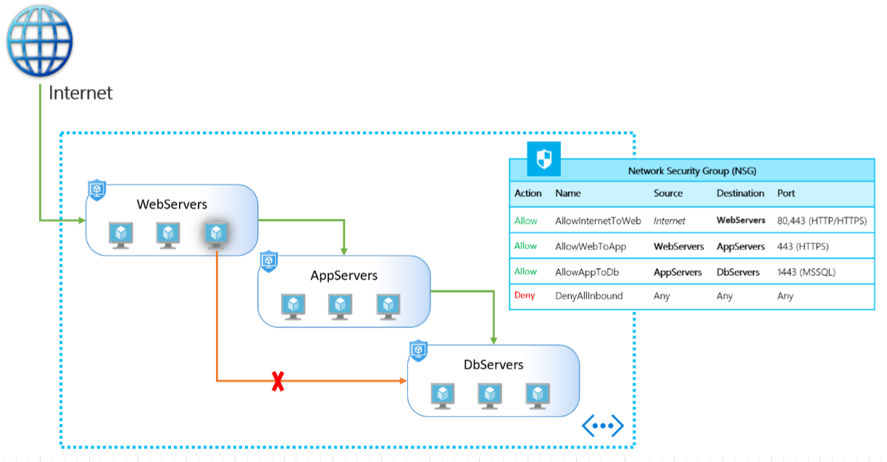

**Choosing an Azure Security Solution**

**Isolation**

Use different virtual networks, or virtual network subnets, to segment your network or isolate resources when required

**Principle of Least Privilege**

Limit each user´s access rights to the bare minimum permissions they need to perform their work

**Use NSGs for Bare Minimum Network Connectivity**

Use Network Security Groups (NSGs) to enforce rules allowing only the minimum network access needed

**Use Azure Firewall and Azure DDoS Protection**

Use Azure Firewall and Azure DDoS protection to protect your resources and prevent large unanticipated costs.

**Azure Identity Services**

**Authentication and Authorization**

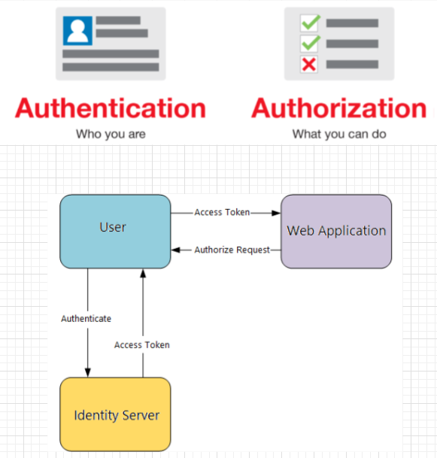

**Azure Multi-Factor Authentication (MFA)**

Requires two or more of the following authentication methods:

-Something you know (typically a password)

-Something you have (a trusted device that is not easily duplicated, like a phone)

-Something you are (biometrics)

**Azure Active Directory (AAD)**

-Comprehensive, highly available Identity and Access Management (IAM) cloud solution

-Fully managed identity service – requires no hardware, virtual machines, etc.

-Main objects are users (pay per user) and groups (free)

-Users are assigned a license based on which edition of Azure AD they should have

-Groups can be assigned multiple licenses, which are inherited by all User in the Group

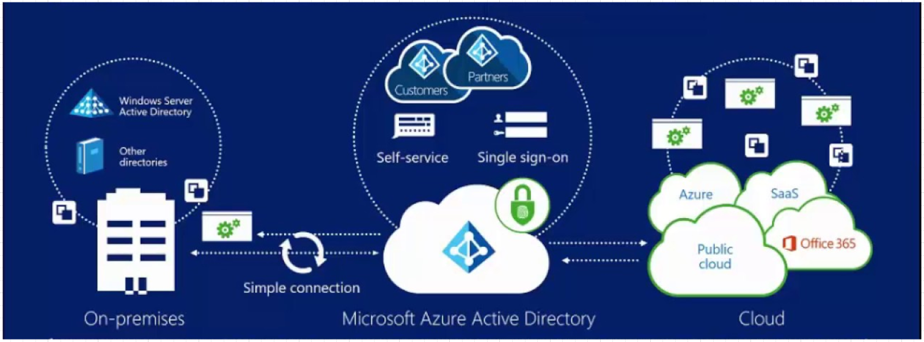

**Azure Security Tools and Features**

**Security in Azure**

Security is built into every layer of Azure.

**Secure Foundation**

State-of-the-art security in Azure data centers around the world, integrated security controls in Azure hardware and firmware components, and protection against threats such as DDoS.

**Simplify Security with Built-In Services**

Easily manage identity and control access, secure your network, safeguard data, manage secrets and certificates, prevent attacks, and gain centralized visibility.

**Detect Threats Early with Unique Intelligence**

Identify new threats and respond quickly with services that are informed by real-time global cybersecurity intelligence.

**Azure Secure Center**

Protects Azure and non-Azure servers and virtual machines including Windows and Linux servers – when Microsoft monitoring Agent is installed

Events collected from Azure and the agents are sent to the security analytics engine, which provides threat detection alerts and tailored recommendations for securing workloads.

Azure PaaS services – including SQL databases and storage accounts – are automatically monitored and protected by Azure Security Center.

**Azure Key Vault**

-Encrypt and safeguard authentication keys, storage account keys, data encryption keys, certificates, and passwords.

-Data is protected by hardware security modules (HSMs)

-Control access to keys using Azure Active Directory.

-Grant access to individual users or to applications and systems.

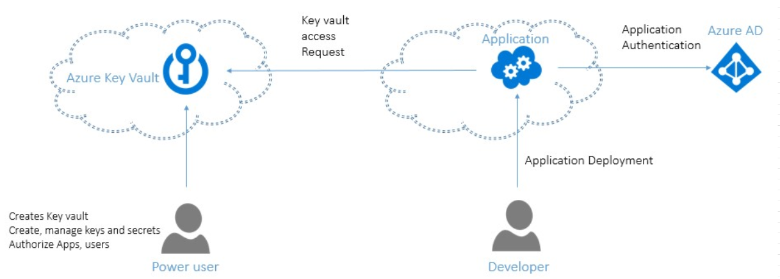

**Azure Information Protection (AIP)**

-Cloud-based solution that helps organizations classify and protect documents and emails.

-Manually or automatically classify sensitive data using 80+ built-in data types (credit card numbers, ID/SSN numbers, etc.)

-Enforce policies on classified data – e.g., require credit card numbers to be encrypted

-Can be retroactively applied to existing documents and emails

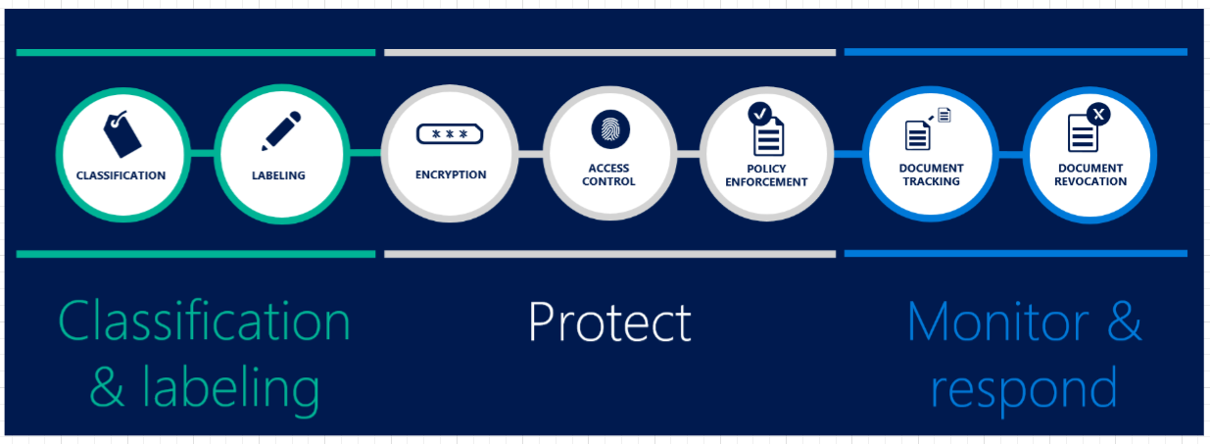

**Azure Advanced Threat Protection (ATP)**

-Cloud-based security solution that identifies, detects, and helps you investigate advanced threats, compromised identities, and malicious insider actions

-Built-in advanced threat detection using data from Azure Active Directory (Azure AD), Azure Monitor logs, and Azure Security Center

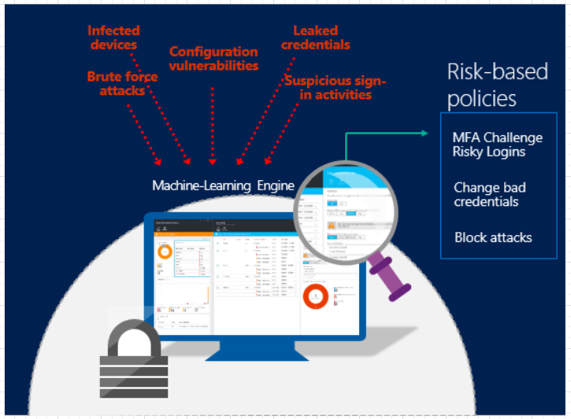

**Azure Governance**

**Azure Policies**

-Service in Azure that you use to create, assign, and manage policies

-Policies enforce different rules for your resources

-Policies can be assigned to Management Groups, Subscriptions, or Resource Groups and are inherited downward

-Evaluate your resources for non-compliance with assigned policies

-Policies can be audited or applied to resources

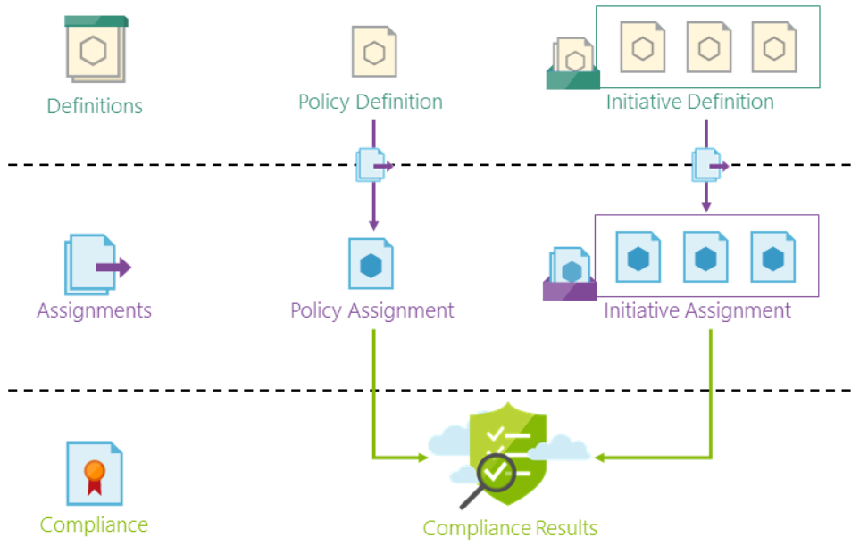

**Azure Initiatives**

-A collection of policy definitions that are tailored toward achieving a single overarching goal

-Simplify managing and assigning policy definitions

-Initiatives can be assigned to Management Groups, Subscriptions, or Resource Groups and are inherited downward

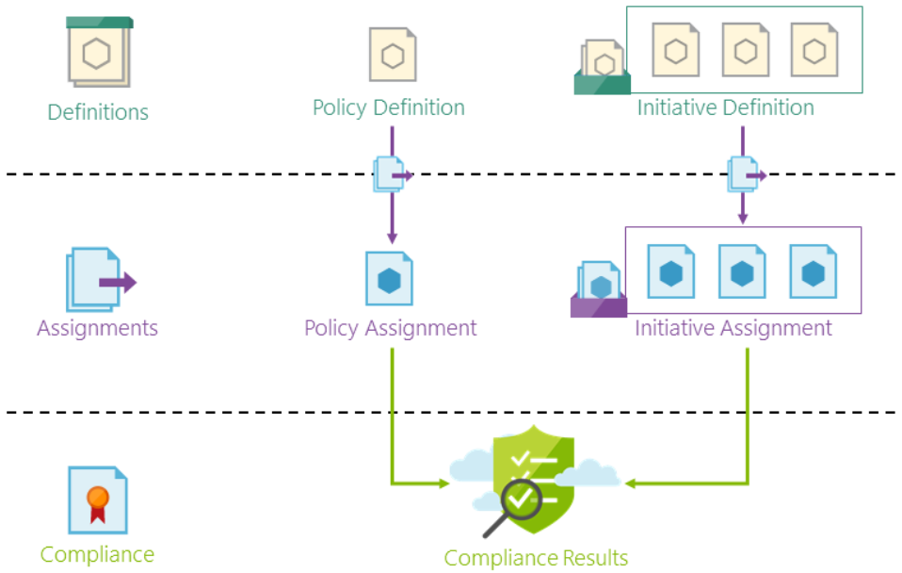

**Roled-Based Access Control (RBAC)**

-An authorization system built on Azure Resource Manager that provides fine-grained access management for Azure resources

-Roles are defined and assigned to a Security Principal: User, Group, or Service Principal (i.e., application account)

-Roles can be scoped to Management Groups, Subscriptions, Resources Groups, or Resources and are inherited downward.

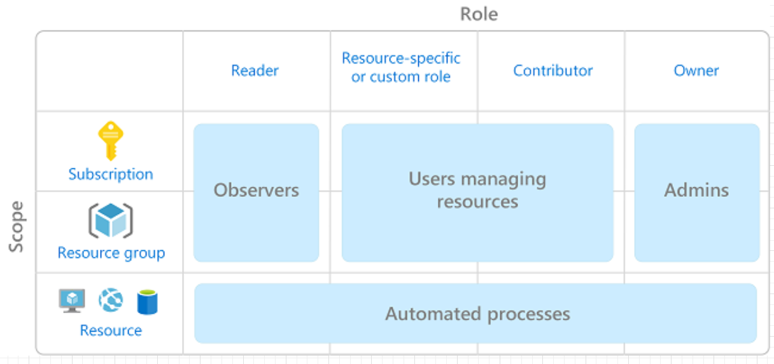

**Resource Locking**

-Prevent other users in your organization from accidentally deleting or modifying critical resources

-Locks can be set to prevent deletion only, or to prevent modifications and deletion

-Locks can be assigned to Management Groups, Subscriptions, Resource Groups, or Resources and are inherited downward.

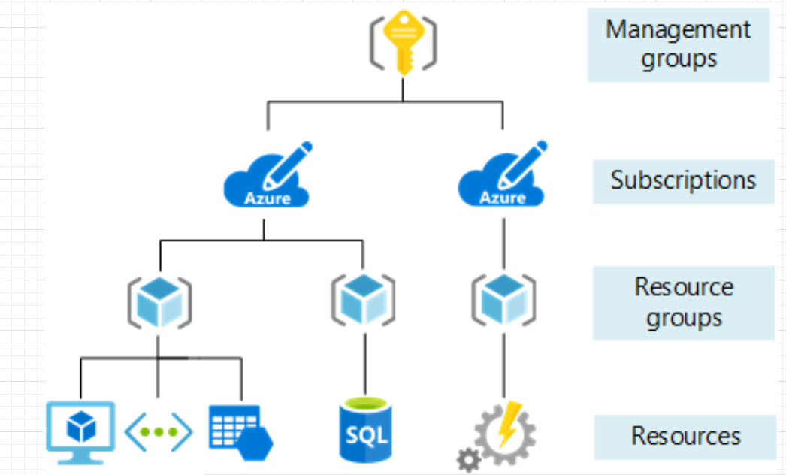

**Security Assistance in Azure Advisor**

-Azure Advisor integrates with Azure Security Center to bring you security recommendations in addition to the high availability, performance, and other recommendations already included in Azure Advisor

-Periodically analyzes the security state of your Azure resources and makes recommendations for any potential security vulnerabilities

**Monitoring and Reporting in Azure**

**Azure Monitor**

-Monitoring platform for all Azure resources

-Allows you to collect granular performance and utilization data, activity and diagnostics logs, and notifications from your Azure resources all in one place

-Helps you understand how your applications are performing and proactively identifies issues affecting them and the resources they depend on

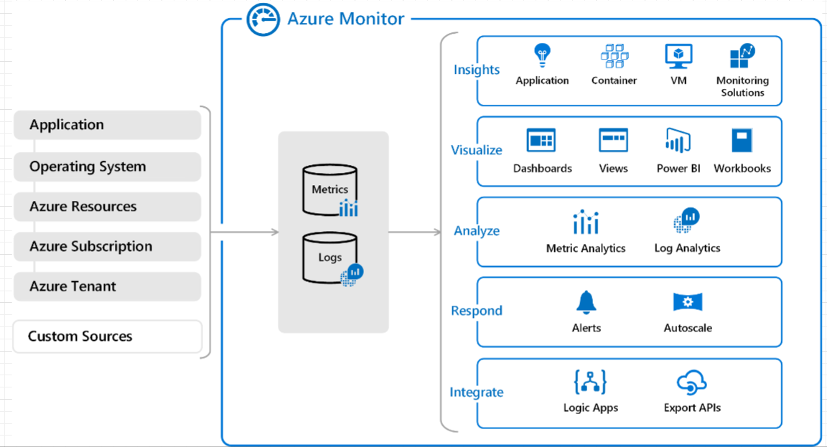

**Azure Service Health**

-Provides a personalized view of the health of the Azure services and regions you-re using

-Tracks three types of health events that may impact your resources:

-**Service issues:** Problems in the Azure services that affect you right now

-**Planned maintenance:** Upcoming maintenance that can affect the availability of your services in the future

-**Health advisories:** Changes in Azure services that require your attention, such as when Azure features are deprecated or you exceed a usage quota

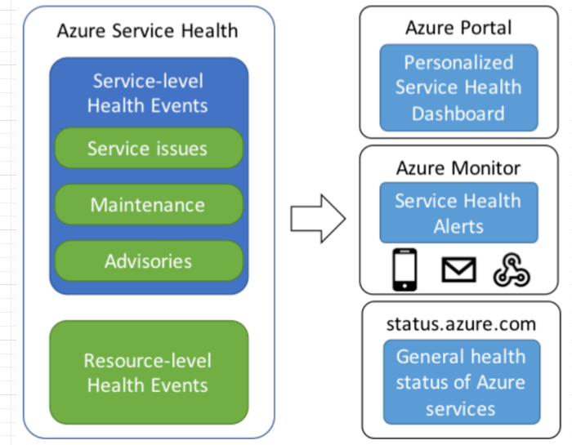

**Azure Monitor and Azure Service Health: Use Cases and Benefits**

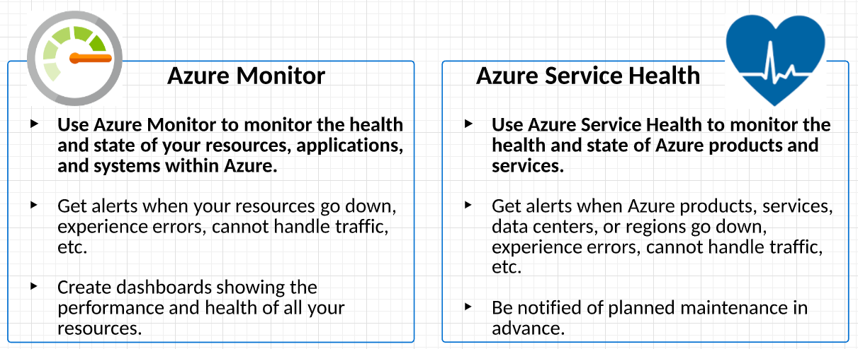

**Best Practice – Use BOTH to:**

-Monitor **all your resources + Azure as a whole** for a comprehensive health monitoring

-Be alerted anytime a failure happens (in your system or in Azure)

-Be notified before planned maintenance and outages

**Azure Privacy, Compliance, and Data Protection Standards**

Industry Compliance: GDPR, ISO, and NIST

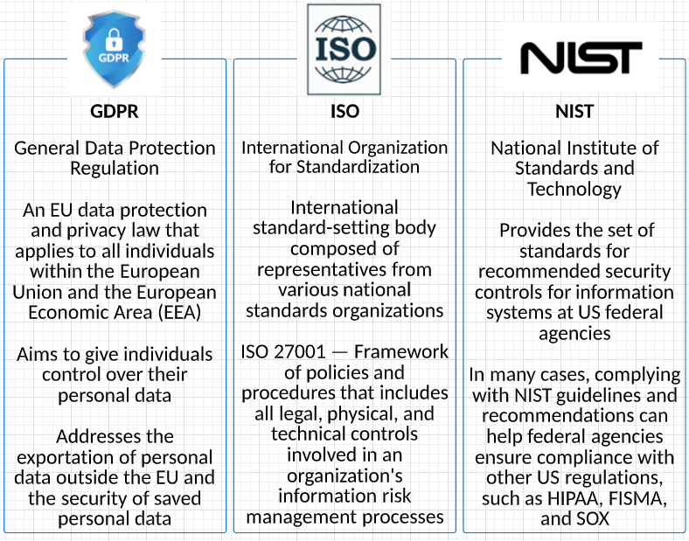

**The Microsoft Privacy Statement**

-Explains the personal data Microsoft processes, how Microsoft processes it, and for what purposes

-Puts Microsoft´s commitment in writing and details data protection policies and practices in clear, straightforward language

-Microsoft will use customer data only to provide the services agreed upon, and for purposes compatible with providing those services

-Microsoft does not use customer data or derive information from it for advertising

-Microsoft will not disclose customer data hosted in Microsoft business services to a government agency unless required by law

-If Microsoft is compelled to disclose customer data to law enforcement, Microsoft will promptly notify the customer and provide a copy of the demand

- <https://privacy.microsoft.com/en-us/privacystatement>

**Microsoft Trust Center**

-Information you need to be confident that the Azure platform on which you run your services is secure

-Security - Learn how all the Microsoft Cloud services are secured

-Privacy - Understand how Microsoft ensures the privacy of your data in the Microsoft cloud

-Compliance - Discover how Microsoft helps organizations comply with national, regional, and industry-specific requirements governing the collection and use of individual´s data

-Transparency - View how Microsoft believes that you control your data in the cloud and how Microsoft helps you know as much as possible about how that data is handled

-Products and Services - See all the Microsoft Cloud products and services in one place

-Service Trust Portal - Obtain copies of independent audit reports of Microsoft cloud services, risk assessments, security best practices, and related materials

-What´s New - Find out what´s new in Microsoft Cloud Trust

-Resources - Check out white papers, videos, and case studies on Microsoft Trusted Cloud

**Microsoft Service Trust Portal**

-Part of the Microsoft Trust Center

-Provides a variety of content, tools, and other resources about Microsoft security, privacy, and compliance practices

-Obtain copies of independent audit reports of Microsoft cloud services, risk assessments, security best practices, and related materials

-Contains details about Microsoft´s implementation of controls and processes that protect cloud services and customer data

**Microsoft Compliance Manager**

-Part of the Microsoft Service Trust Portal

-Fully managed solution that helps you manage the end-to-end regulation-to-audit compliance process

-Workflow-based risk assessment tool that enables you to track, assign, and verify your organization´s regulatory compliance activities related to Microsoft Azure

-Provides recommended actions and a control management tool for your organization to improve data protection capabilities and seamlessly implement controls across teams

-Enables you to perform real-time risk assessment to help you be better prepared for auditing

**Determining Azure Compliance for Business Needs**

Use the Microsoft Service Trust Portal to find:

-Industry-specific landing pages for information about how Microsoft Cloud services help your organization be compliant with standards and regulations for those industries

-Legal opinions on Microsoft Cloud services compliance with the laws of various countries, including Australia, the Czech Republic, Germany, Poland, Romania, Spain, and the United Kingdom.

-A wealth of security implementation and design information that makes it easier for you to meet regulatory compliance objectives. These include white papers, how-to-articles, compliance guides, pen tests and security assessments, and auditing templates and solutions.

-Capabilities in Microsoft Cloud services that you can use to address specific requirements, such as the GDPR

**Azure Governments Services**

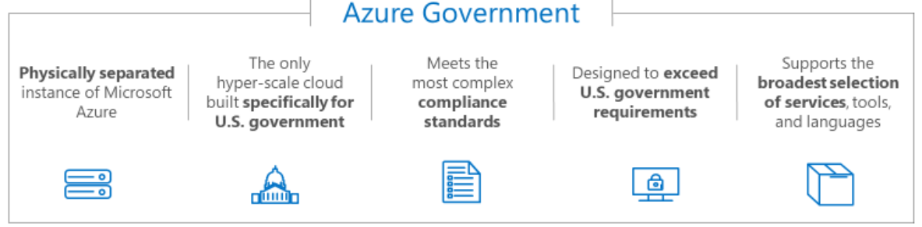

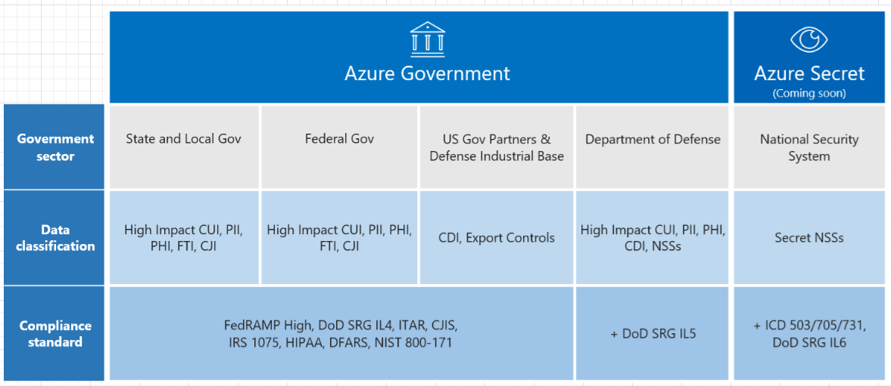

**Azure Germany Services**

-When it comes to data protection and security, Germany is one of the most heavily regulated countries in the world

-GDPR and German regulations require all personal data of Germans to be stored in Germany and owned by a Germany company

-Microsoft partnered with German companies to comply with all German regulations, building 2 distinct data centers for a German-only part of Azure

-As of 2017, Azure Germany Services is being phased out by Microsoft - they are no longer accepting new users.

**Azure Pricing and Support**

**Azure Subscriptions**

-An Azure account is a unique global entity that gives you access to your Azure subscriptions

-In each of your subscriptions, you can manage resources using resource groups

-Subscriptions have a single offer type: Enterprise Agreement, Certified Solution Partner, Pas-As-You-Go, etc.

-You can create multiple subscriptions in your Azure account to create separation for billing or management purposes

-Azure subscriptions can have a trust relationship with an Azure Active Directory (Azure AD) instance

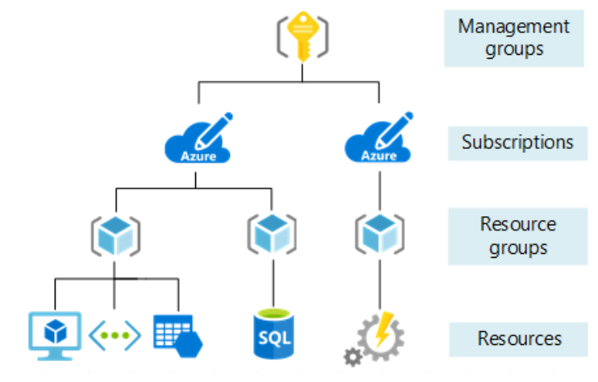

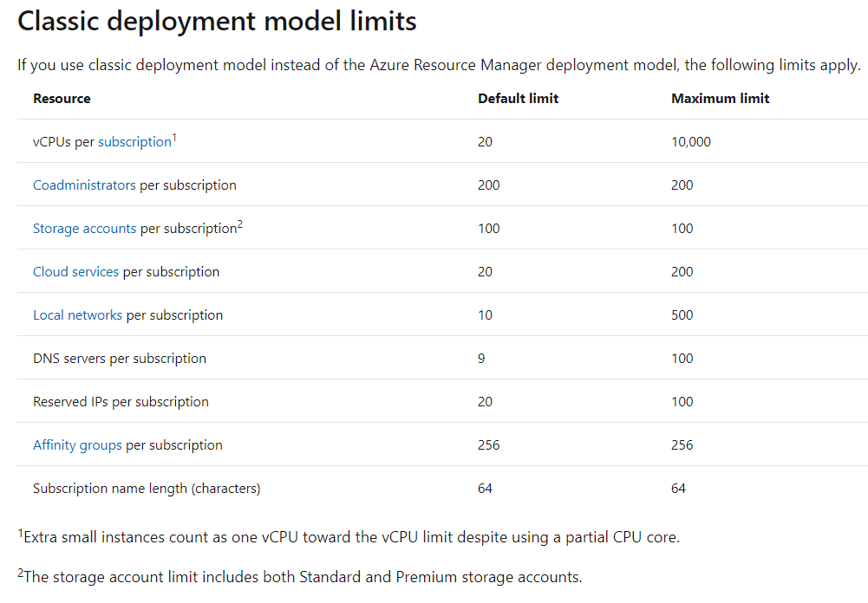

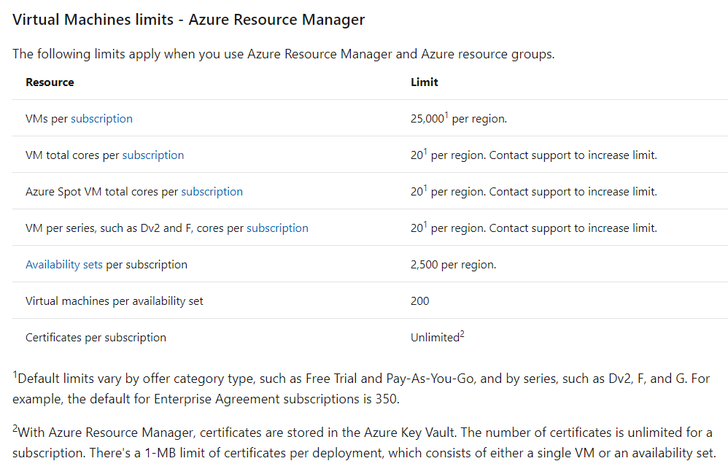

**Azure Subscriptions Options and Uses**

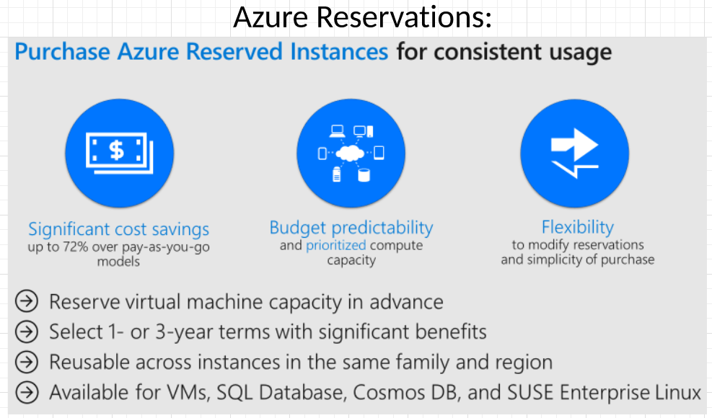

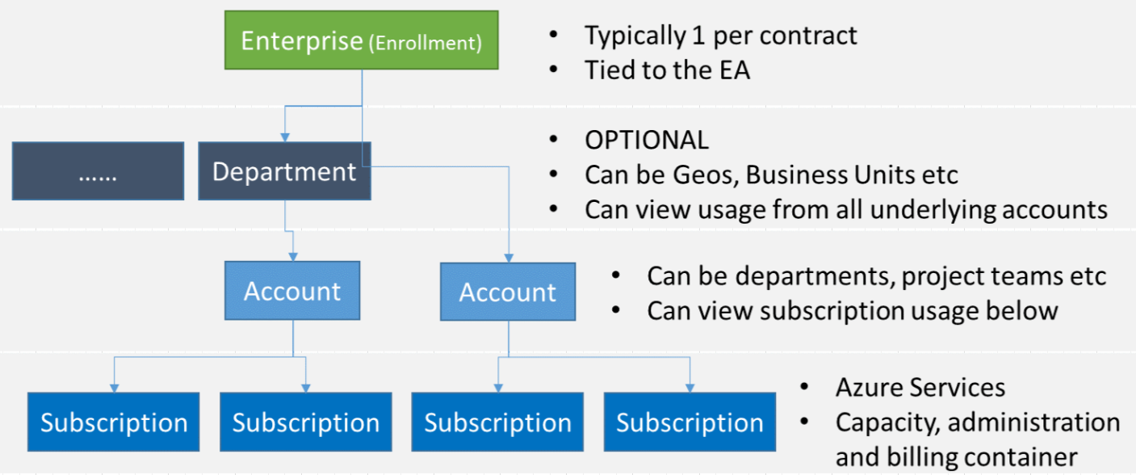

**Planning and Managing Azure Costs**

**Purchasing Azure Products and Services**

Purchase Azure directly from Microsoft:

-Get a monthly bill from Microsoft for the Azure services you consume

-Option to choose a Microsoft support plan for Azure

Purchase Azure as part of a managed service from a Microsoft partner:

-Get your bill from and pay for Azure usage through you CSP

-Get support for Azure through your CSP

Azure partners have experience helping businesses save time and money

Pricing depends on subscription type and, in some cases, region.

Prepay and save even more with 1-3 year commitments (Azure reservations)

**The Azure Free Account**

-One-time offer per account for free access to many Azure products

-Your subscription starts with the "Free Trial" offer

-Get a $200 credit to spend in the first 30 days

-Get 12 months of free Azure compute time and other resources

-After 30 days, you must upgrade your subscription to "pay-as-you-go" and remove the spending limit, or your free account will be disabled

-As long as you stay within the quotas for the 12 months of free Azure resources, you won´t be charged

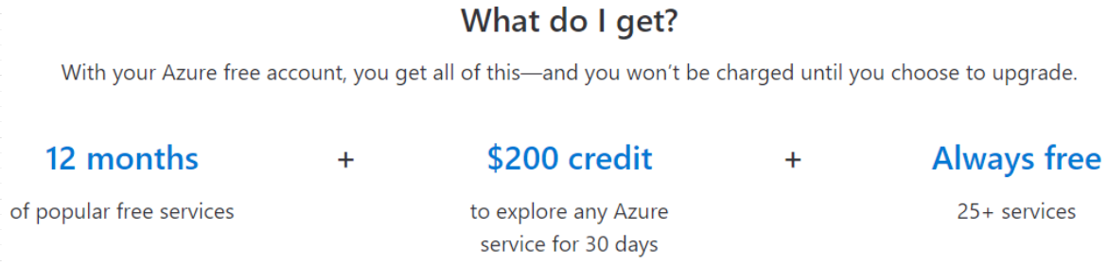

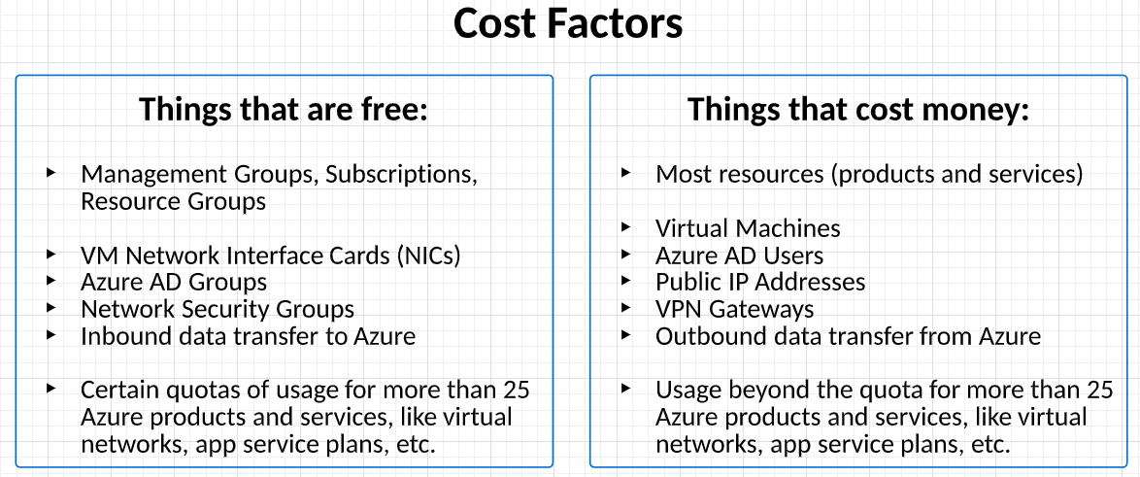

**Billing Zones**

-For data transfer in/out of Azure, the following regions correspond to different Azure Billing Zones and charge different prices:

-Zone 1 - Canada, Europe, UK, US, US Government, US DoD

-Zone 2 - Asia, Australia, India, Japan, Korea

-Zone 3 - Brazil

-DE Zone - Germany

-China Zone - China

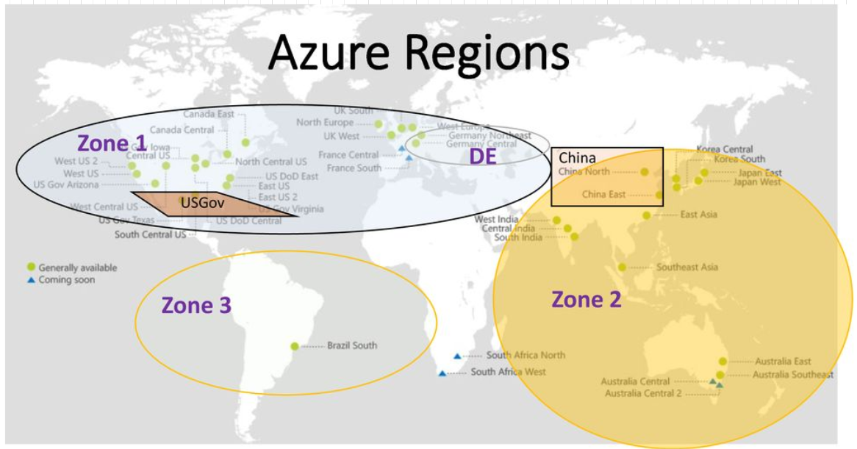

**Pricing Calculator**

-Estimate your Azure consumption using the free Azure pricing calculator

-Estimate the pricing for each product or service in your solution

-Example: A running virtual machine consumes virtual machine capacity, disk storage, table storage (performance metrics), a public IP address, and some other micro-charges

-See a full estimate of all your total costs and export to Excel

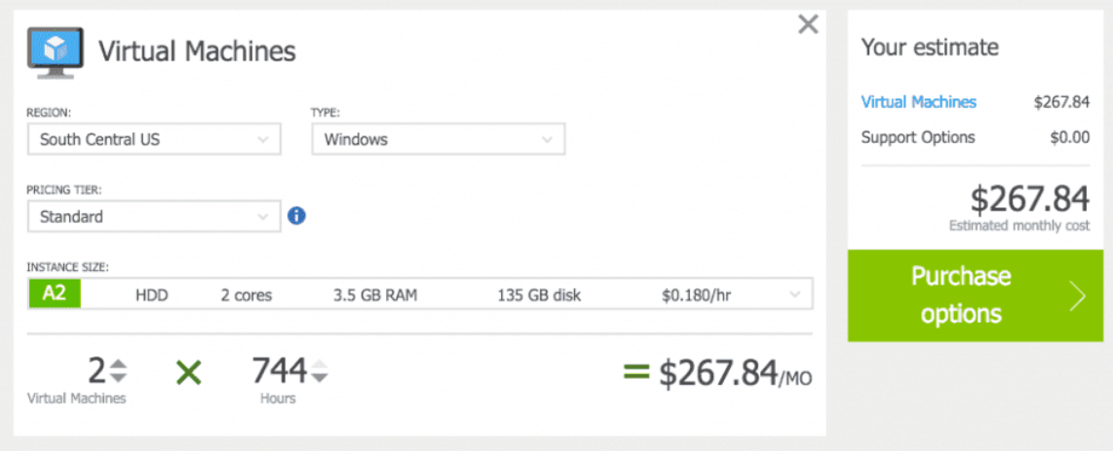

**Total Cost of Ownership (TCO) Calculator**

-Estimate the cost saving you can have by migrating your workloads to Azure

-Enter the details of your on-premises workloads and see your current TCO, as well as recommended services in Azure and their TCO

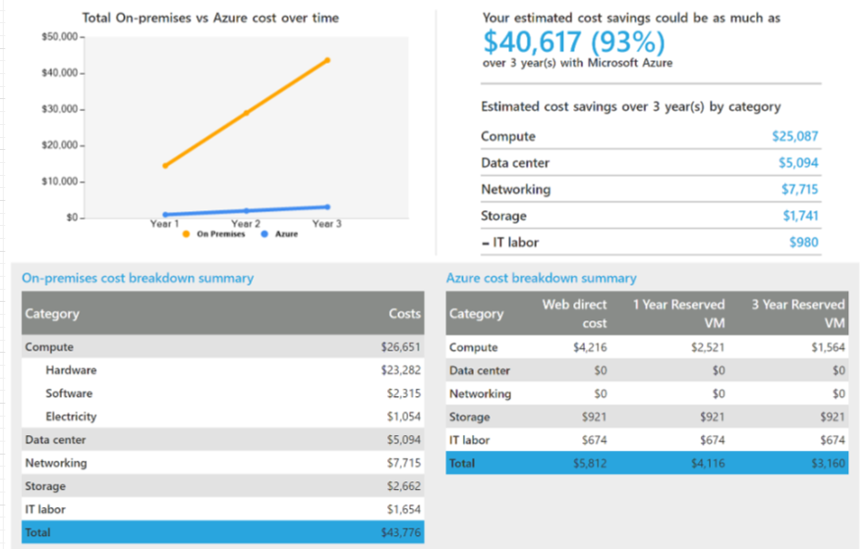

**Minimizing Azure Costs**

-Minimizing costs is a continuous process.

-Set up your resources with costs in mind - add tags to your resources to group your billing data

-Regularly check the portal for cost breakdown and burn rate

-Consider enabling cost-cutting features like auto-shutdown for VMs

-Turn on and check out Azure Advisor recommendations

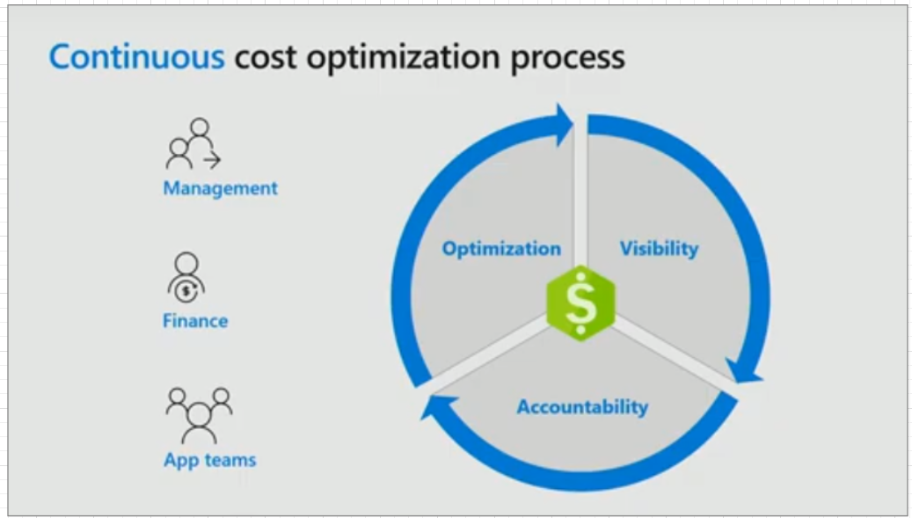

**Azure Cost Management**

-Helps you analyze costs, create and manage budgets, export data, and review and act on optimization recommendations to save money

-Recommendations come from Azure Advisor and show how you can optimize and improve efficiency by identifying idle and under-utilized resources

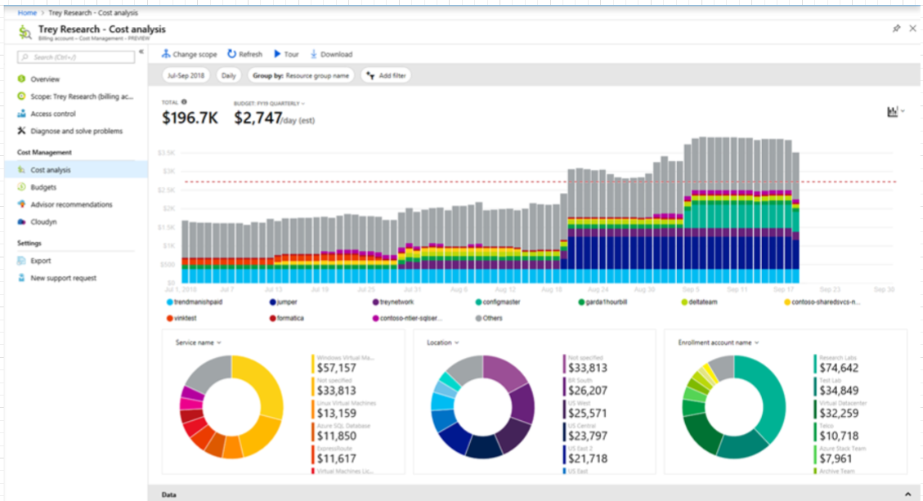

**Azure Support Options**

**Azure Support Plans**

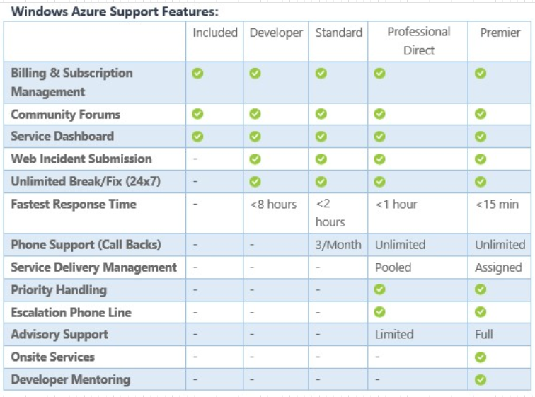

**Opening an Azure Support Ticket**

Azure customers with a support plan can create and manage support requests in the Azure portal (<https://portal.azure.com>)

The Azure support request experience is:

-Streamlined: Reduce clicks and blades to make the process of submitting a support request simple

-Integrated: When you're troubleshooting an issue with an Azure resource, it should be easy to open a support request for that resource without switching context

-Efficient: Gather the key information your support engineer needs to efficiently resolve your issue

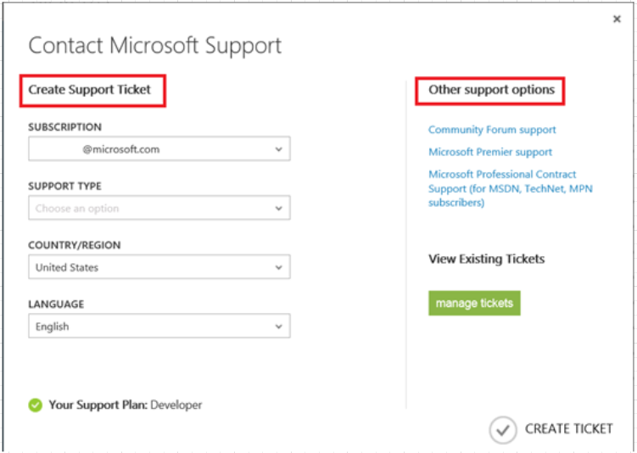

**Additional Azure Support Channels**

-Azure Knowledge Center - Get answers to common support questions

-You can raise questions in two different Azure forum options (MSDN and Stack Overflow) to connect with other Azure customers and experts to ask questions, share experiences, or find solutions

-If you are a member of certain programs like MPN, MSDN, or BizSpark, you may eligible for limited Azure Support benefits from those programs even if you don't have a support plan

-Your Azure subscription includes access to subscription management support (e.g., billing, quota adjustment, account transfer) at no additional cost

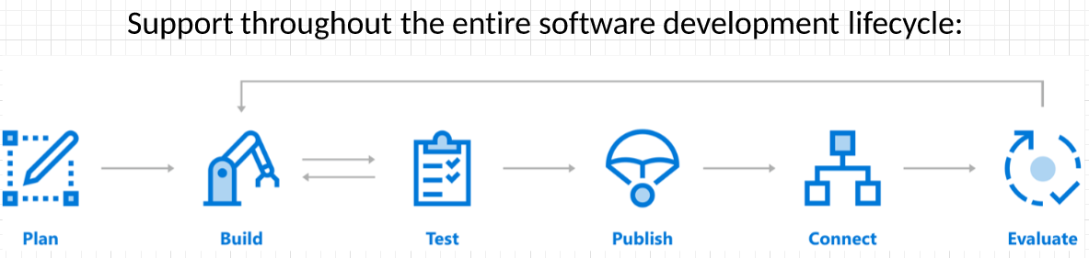

**The Azure Knowledge Center**

-Get answers to common support questions

-Available 24/7/365

-Search across different products and services, or search by tags to find information for related products and services

-One of many free resources for Azure information and support

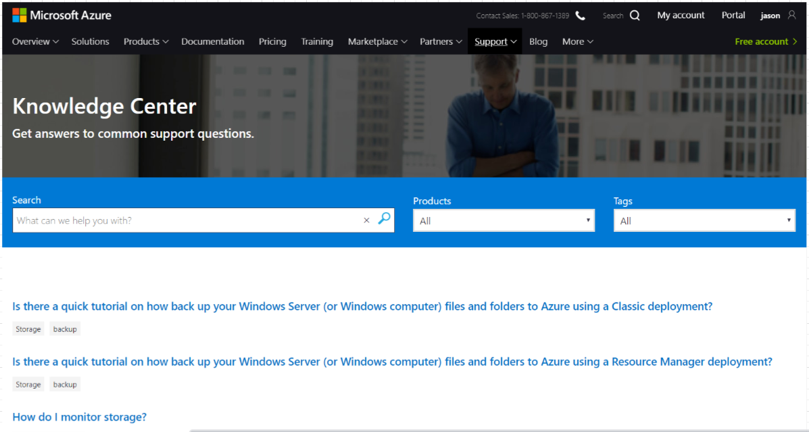

**Azure Service Level Agreements (SLAs)**

**Azure Service Level Agreements (SLAs)**

-Uptime is guaranteed (not performance, bandwidth, or feature availability)

-Expressed as a percentage of the total time per month that the service is guaranteed to be up

-If an incident causes the uptime to fall below the SLA guarantee, you are entitled to a credit towards your monthly service fees

-Monthly Uptime % = (Maximum Available Minutes - Downtime) / Maximum Available Minutes * 100

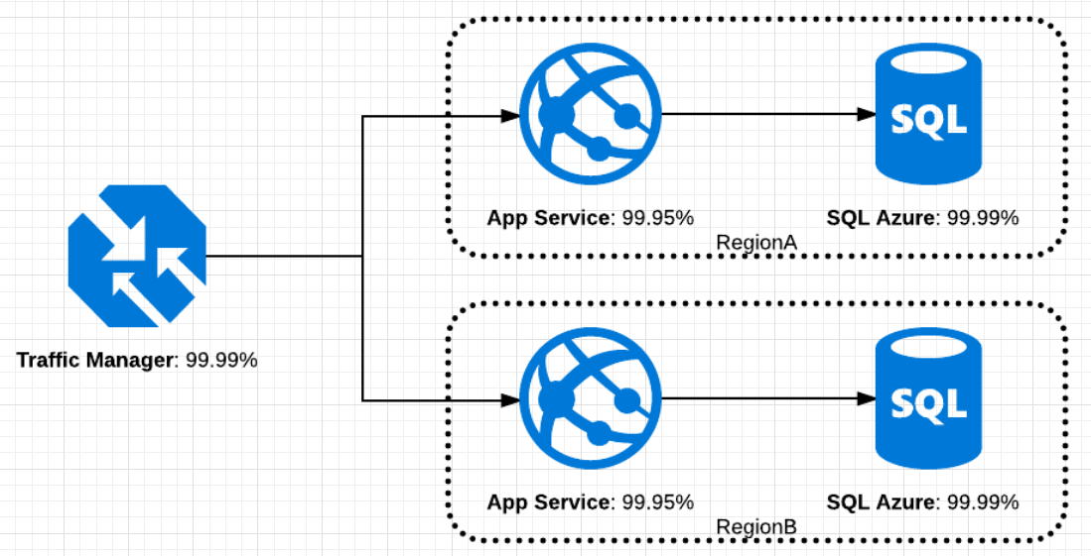

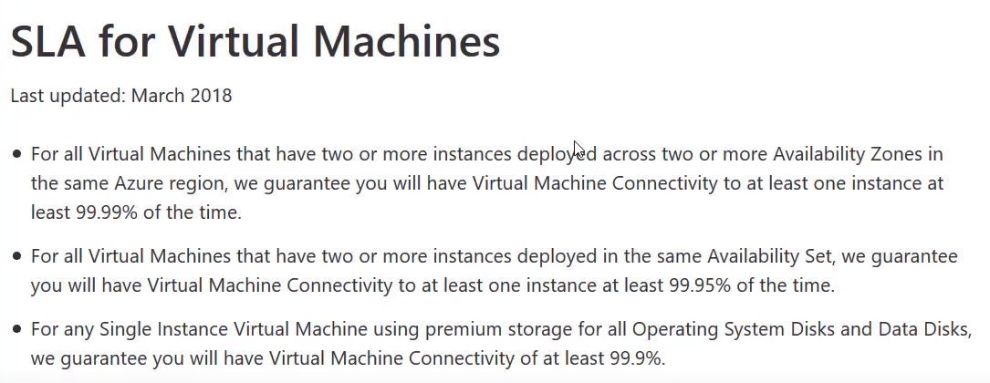

**Finding the SLA for Azure Products and Services**

-Each Azure product and service has a separate SLA

-Certain Azure products and services can be configured in different ways for different SLAs. For example, CosmosDB has a 99,99% SLA, but if configured to use multiple regions, the SLA is 99,999%.

-You can find the SLA for all Azure products and services on the Azure SLA landing page:

<https://azure.microsoft.com/en-us/support/legal/sla/>

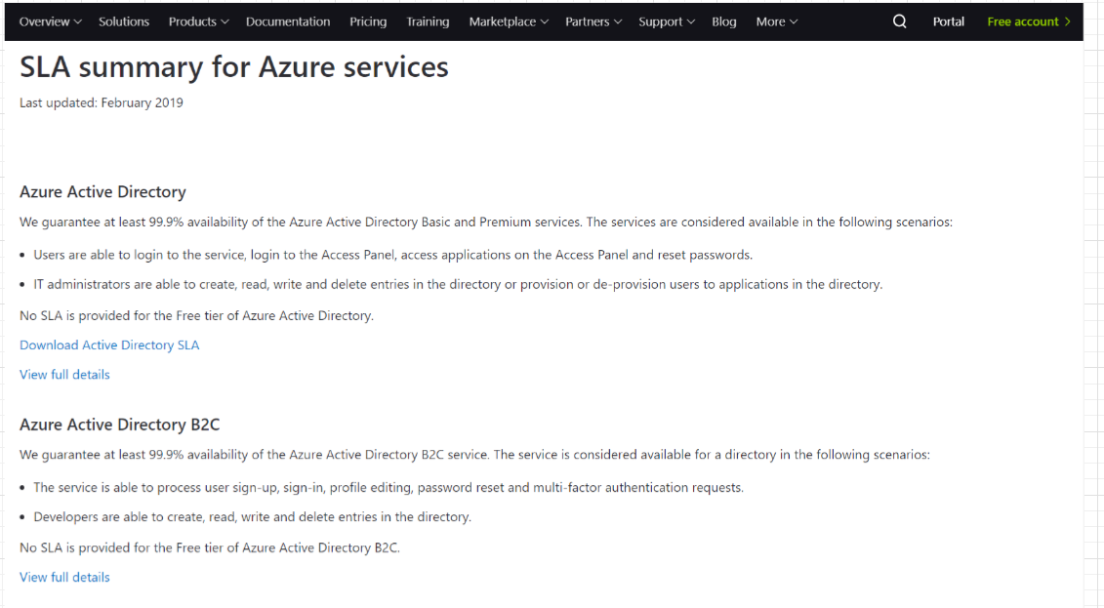

**The Azure Service Lifecycle**

**Public and Private Private Features**

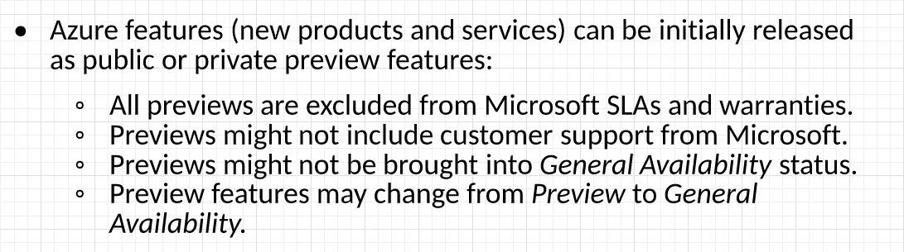

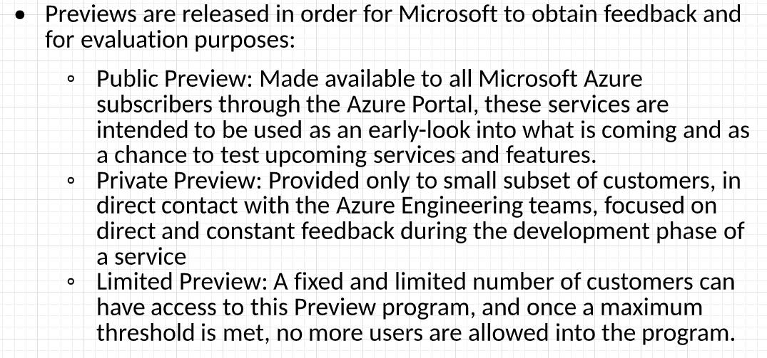

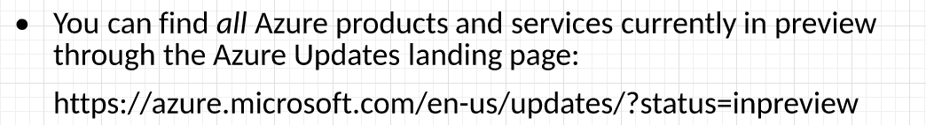

**Accessing Preview Features**

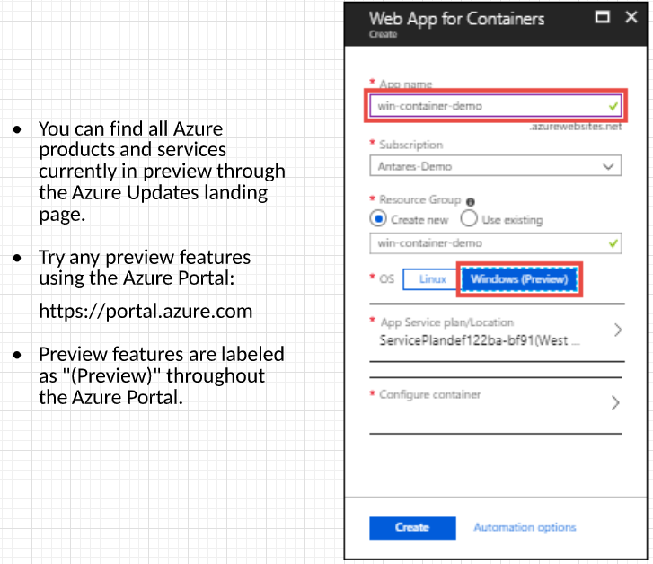

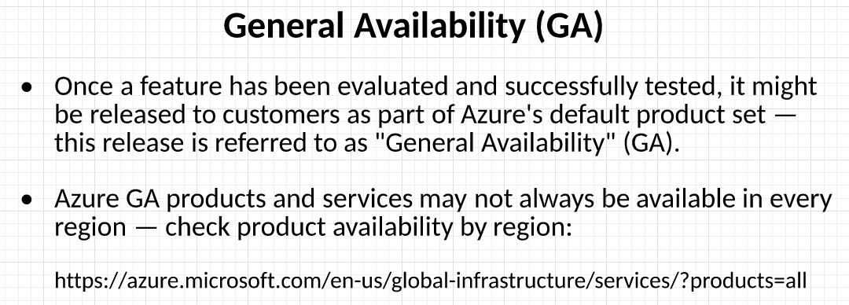

**Monitoring Features Updates**

